**CHAPTER 1**

**INTRODUCTION**

**1.1 OVERVIEW**

Cloud storage is a platform to provide large scale data storage and service access at a “pay-as-you-go” fashion. However, a lot of redundant data in cloud storage has seriously wasted and occupied storage resources. Data deduplication is an effective technology to detect and eliminate redundant data. After that, only a single copy of the data is uploaded and stored. Thus, the data deduplication technology can reduce the bandwidth requirement of client-side and improve the space utilization efficiency of server-side. Currently, it has widely used in various cloud computing services to improve user experience and save storage space. The classic data deduplication scheme and its variants, where the framework consists of a key server (KS), a cloud storage provider (CSPs), and users, ensure the security depending on the trusted KS. What is worse, these classic schemes may suffer from the single-point-of-failure and “platform lock-in” issues. If the trusted KS fails, the cloud storage system stops working and data outsourcing protocols cannot be implemented.

Recently, a new model of cloud computing, called as JointCloud computing system has been designed to solve the above-mentioned issues well. The network architecture of JointCloud consists of users and multiple CSPs providing various services. These clouds collaborate together without the trusted KS and the users can connect with any one of them to get computing services. Obviously, Joint Cloud can provide efficient cross-cloud services and satisfy the requirements of globalized cooperative cloud services by the multilateral collaboration among various clouds. Moreover, it can be built in the decentralized system. Joint Cloud computing has drawn a lot of attention from both academia and industry. A massive data breach incidents affecting billions of personal data are far common. Therefore, the outsourced data are usually asked to be encrypted to ensure data confidentiality in cloud storage systems. However, it is difficult to detect and delete the duplicated copies in the ciphertext domain. Because the cipher texts of the same plaintext encrypted by different users using traditional encryption algorithms are different. In order to implement encrypted deduplication, convergent encryption (CE) and its variant have been proposed. In these schemes, data are encrypted using the keys derived from the data themselves. That is, the secret key is deterministic and the scheme is vulnerable. Specifically, there are some security vulnerabilities, e.g., 1) the tag reveals the hash value of plaintext, which is vulnerable to the chosen-plaintext attack; 2) the ciphertext dissatisfies the semantic security; 3) the predictable plaintext cannot resist the brute-force attack; 4) users have to bear a great computational burden to protect their data against malicious attackers, etc.

The previous solutions to overcome the above issues roughly fall into two categories and their limitations are explained below. The one type of solution improves the security of outsourced data by limiting the manners of data accessibility and availability in the classic system model. That is, they use key management and access control techniques to manage encryption keys and ensure outsourced data access security. Nevertheless, these schemes usually have high computational complexity. and communication cost because of sharing a lot of keys and storing auxiliary information. The other type of solution designs new system models to improve the security and functionality. Users have to interact with multiple trusted key servers (KSs) to perform deduplication. It is obvious that the multiple interactions between the client-side and the server-sides also increase the chance of being attacked users. Moreover, most prior schemes still cannot solve the single-point-of-failure. Besides, in the Joint Cloud system, users’ data may be stored in one of multiple clouds or scattered around multiple clouds.

The classic deduplication schemes cannot be directly applied to the Joint Cloud system. Motivated by the above issues, we design a Secure and Efficient data Deduplication scheme (SED) based on the Joint Cloud system model. The design goals of our SED include security, functionality, and efficiency. Specifically, 1) in terms of security, our SED implements secure data outsourcing and deduplicating without the trusted key server, and it should ensure data confidentiality and integrity and prevent data from attacks. 2) In terms of functionality, our SED should support that the data stored in multiple CSPs can be renewable, shared, and access controlled. That is, the data owners can update and share their outsourced data wherever they are stored, but the non-owners cannot efficiently access and manipulate any outsourced data. 3) In terms of efficiency, our SED should implement these operations such as uploading, deduplicating, updating, and sharing with low computational overhead. The encryption algorithm and the tag generation algorithm of the proposed SED ensure the semantic security. Moreover, SED can resist the typical attacks such as the brute-force attack, tampering attack, and collusion attack. The SED implements secure deduplication without the help of the trusted key server. It also supports data updating and sharing cross-clouds. Furthermore, SED solves the single-point-of-failure issue and improves the scalability of the classic deduplication scheme.

The proposed system is a secure and efficient data deduplication scheme SED without the help of the trusted KS in the JointCloud storage system. Some sub-algorithms of our SED are inspired by the fully randomized tag generation algorithm which helps with duplicates detection and protects the outsourced data against the collusion attacks. Different from the previous deduplication schemes, the SED ensures that the ciphertext and the tag can satisfy semantic security. Any adversary cannot get any useful information from the tag and ciphertext. Moreover, the SED is the first scheme that supports data update and data sharing securely. In SED, it design the encryption algorithm that supports data deduplication, update, and sharing. To the best of our knowledge, SED is the first scheme considering the case that data owner shares his/her outsourced data to permitted users. Especially, a master encryption key is generated by the collaboration of the participating CSPs. It ensures the flexibility and security of key generation. The data access control based on authentication of SED also helps with the implementation of data update and sharing operations. Then, SED combines the intra-deduplication and inter-deduplication techniques to eliminate duplicates in the Joint Cloud system, which improves the efficiency of data deduplication

**CHAPTER 2**

**LITERATURE REVIEW**

**2.1 A survey of indexing techniques for scalable record linkage and deduplication**

Record linkage is the process of matching records from several databases that refer to the same entities. When applied on a single database, this process is known as deduplication. Increasingly, matched data are becoming important in many application areas, because they can contain information that is not available otherwise, or that is too costly to acquire. Removing duplicate records in a single database is a crucial step in the data cleaning process, because duplicates can severely influence the outcomes of any subsequent data processing or data mining. With the increasing size of today's databases, the complexity of the matching process becomes one of the major challenges for record linkage and deduplication.

(P. Christen 2012) In recent years, various indexing techniques have been developed for record linkage and deduplication. They are aimed at reducing the number of record pairs to be compared in the matching process by removing obvious nonmatching pairs, while at the same time maintaining high matching quality. This paper presents a survey of 12 variations of 6 indexing techniques. Their complexity is analyzed, and their performance and scalability is evaluated within an experimental framework using both synthetic and real data sets. No such detailed survey has so far been published.

**2.2 Coordinate memory deduplication and partition for improving performance in cloud computing**

Both limited main memory size and memory interference are considered as the major bottlenecks in virtualization environments. Memory deduplication, detecting pages with same content and being shared into one single copy, reduces memory requirements; memory partition, allocating unique colors for each virtual machine according to page color, reduces memory interference among virtual machines to improve performance. In this paper, we propose a coordinate memory deduplication and partition approach named CMDP to reduce memory requirement and interference simultaneously for improving performance in virtualization. Moreover, CMDP adopts a lightweight page behavior-based memory deduplication approach named BMD to reduce futile page comparison overhead meanwhile to detect page sharing opportunities efficiently.

(G. Jia, G. Han 2019) And a virtual machine based memory partition called VMMP is added into CMDP to reduce interference among virtual machines. According to page color, VMMP allocates unique page colors to applications, virtual machines and hypervisor. The experimental results show that CMDP can efficiently improve performance (by about 15.8 percent) meanwhile accommodate more virtual machines concurrently.

**2.3 The design of fast content-defined chunking for data deduplication based storage systems**

Content-Defined Chunking (CDC) has been playing a key role in data deduplication systems recently due to its high redundancy detection ability. However, existing CDC-based approaches introduce heavy CPU overhead because they declare the chunk cut-points by computing and judging the rolling hashes of the data stream byte by byte. In this article, we propose FastCDC, a Fast and efficient Content-Defined Chunking approach, for data deduplication-based storage systems.

(W. Xia, X. Zou 2020) The key idea behind FastCDC is the combined use of five key techniques, namely, gear based fast rolling hash, simplifying and enhancing the Gear hash judgment, skipping sub-minimum chunk cut-points, normalizing the chunk-size distribution in a small specified region to address the problem of the decreased deduplication ratio stemming from the cut-point skipping, and last but not least, rolling two bytes each time to further speed up CDC. Our evaluation results show that, by using a combination of the five techniques, FastCDC is 3-12X faster than the state-of-the-art CDC approaches, while achieving nearly the same and even higher deduplication ratio as the classic Rabin-based CDC. In addition, our study on the deduplication throughput of FastCDC-based Destor (an open source deduplication project) indicates that FastCDC helps achieve 1.2-3.0X higher throughput than Destor based on state-of-the-art chunkers.

**2.4 Secure auditing and deduplicating data in cloud**

As the cloud computing technology develops during the last decade, outsourcing data to cloud service for storage becomes an attractive trend, which benefits in sparing efforts on heavy data maintenance and management. Nevertheless, since the outsourced cloud storage is not fully trustworthy, it raises security concerns on how to realize data deduplication in cloud while achieving integrity auditing.

(J. Li, J. Li 2016) In this work, we study the problem of integrity auditing and secure deduplication on cloud data. Specifically, aiming at achieving both data integrity and deduplication in cloud, we propose two secure systems, namely SecCloud and SecCloud + . SecCloud introduces an auditing entity with a maintenance of a MapReduce cloud, which helps clients generate data tags before uploading as well as audit the integrity of data having been stored in cloud. Compared with previous work, the computation by user in SecCloud is greatly reduced during the file uploading and auditing phases. SecCloud + is designed motivated by the fact that customers always want to encrypt their data before uploading, and enables integrity auditing and secure deduplication on encrypted data.

**2.5 Keyd: Secure key-deduplication with identity-based broadcast encryption**

Deduplication, which can save storage cost by enabling us to store only one copy of identical data, becomes unprecedentedly significant with the dramatic increase in data stored in the cloud. For the purpose of ensuring data confidentiality, they are usually encrypted before outsourced. Traditional encryption will inevitably result in multiple different ciphertexts produced from the same plaintext by different users' secret keys, which hinders data deduplication. Convergent encryption makes deduplication possible since it naturally encrypts the same plaintexts into the same ciphertexts. One attendant problem is how to reliably and effectively manage a huge number of convergent keys. Several deduplication schemes have been proposed to deal with the convergent key management problem. However, they either need to introduce key management servers or require interaction between data owners.

(L. Liu, Y. Zhang 2018) In this paper, we design a novel client-side deduplication protocol named KeyD without such an independent key management server by utilizing the identity-based broadcast encryption (IBBE) technique. Users only interact with the cloud service provider (CSP) during the process of data upload and download. Security analysis demonstrates that KeyD ensures data confidentiality and convergent key security, and well protects the ownership privacy simultaneously. A thorough and detailed performance comparison shows that our scheme makes a better tradeoff among the storage cost, communication and computation overhead.

**2.6 Message-locked encryption for lock-dependent messages**

Motivated by the problem of avoiding duplication in storage systems, Bellare, Keelveedhi, and Ristenpart have recently put forward the notion of Message-Locked Encryption (MLE) schemes which subsumes convergent encryption and its variants. Such schemes do not rely on permanent secret keys, but rather encrypt messages using keys derived from the messages themselves.

(M. Abadi, D. Boneh 2013) We strengthen the notions of security proposed by Bellare et al. by considering plaintext distributions that may depend on the public parameters of the schemes. We refer to such inputs as lock-dependent messages. We construct two schemes that satisfy our new notions of security for message-locked encryption with lock-dependent messages. Our main construction deviates from the approach of Bellare et al. by avoiding the use of ciphertext components derived deterministically from the messages. We design a fully randomized scheme that supports an equality-testing algorithm defined on the ciphertexts.

Our second construction has a deterministic ciphertext component that enables more efficient equality testing. Security for lock-dependent messages still holds under computational assumptions on the message distributions produced by the attacker. In both of our schemes the overhead in the length of the ciphertext is only additive and independent of the message length.

**2.7 Achieving efficient secure deduplication with user-defined access control in cloud**

Cloud storage as one of the most important services of cloud computing which significantly facilitates cloud users to outsource their data to the cloud for storage and share them with authorized users. In cloud storage, secure deduplication has been widely investigated as it can eliminate the redundancy over the encrypted data to reduce storage space and communication overhead. Regarding the security and privacy, many existing secure deduplication schemes generally focus on achieving the following properties: data confidentiality, tag consistency, access control, and resistance to brute-force attacks.

(X. Yang, R. Lu 2020) However, as far as we know, none of them can achieve these four requirements at the same time. To overcome this shortcoming, in this article, we propose an efficient secure deduplication scheme that supports user-defined access control. Specifically, by allowing only the cloud service provider to authorize data access on behalf of data owners, our scheme can maximally eliminate duplicates without violating the security and privacy of cloud users. Detailed security analysis shows that our authorized secure deduplication scheme achieves data confidentiality and tag consistency while resisting brute-force attacks. Furthermore, extensive simulations demonstrate that our scheme outperforms the existing competing schemes, in terms of computational, communication and storage overheads as well as the effectiveness of deduplication

**2.8 Efficient selective-id secure identity-based encryption without random oracles**

We construct two efficient Identity Based Encryption (IBE) systems that are selective identity secure without the random oracle model. Selective identity secure IBE is a slightly weaker security model than the standard security model for IBE

(B. Dan and X. Boyen 2004) . In this model the adversary must commit ahead of time to the identity that it intends to attack, whereas in the standard model the adversary is allowed to choose this identity adaptively. Our first secure IBE system extends to give a selective identity Hierarchical IBE secure without random oracles.

**2.9 Secure data deduplication with dynamic ownership management in cloud storage**

In cloud services, deduplication technology is commonly used to reduce the space and bandwidth requirements services by eliminating redundant data and storing only single copy. Deduplication is most effective when multiple users outsource the same data to the cloud storage, but raises issues relating to security and ownership.

(J. Hur, D. Koo 2004) Proof-of-ownership schemes allow any owner of the same data to prove to the cloud storage server that he owns the data in a robust way. However, if encrypted data is outsourced into the cloud storage and the ownership changes dynamically, deduplication would be hampered. Thus, we propose a secure deduplication scheme that supports dynamic ownership management based on randomized convergent encryption in this study.

**2.10 3 Decentralized server-aided encryption for secure deduplication in cloud storage**

Cloud storage provides scalable and low cost resources featuring economies of scale based on multi-tenant architecture. As the amount of data outsourced grows explosively, data deduplication, a technique that eliminates data redundancy, becomes essential. However, deduplication leads to problems with data confidentiality, thereby necessitating secure deduplication solutions. Server-aided encryption schemes have been proposed to achieve the strongest confidentiality but with the cost of managing a key server (KS). Previous schemes, however, are based on a centralized KS that uses only a single secret key assuming a single KS in the system. In cloud storage where multi-tenancy and scalability are crucial, such schemes degrade not only the effectiveness of deduplication but also the scalability with increasing users.

(Y. Shin, D. Koo 2020) In this paper, we extend server-aided encryption to a decentralized setting that consists of multiple KSs. The key idea of our proposed scheme is to construct an inter-KS deduplication algorithm, by which a cloud storage service provider can perform deduplication over ciphertexts from different KSs within a tenant or across tenants. This way, our scheme simultaneously offers flexibility of KS management and cross-tenant deduplication over encrypted data. The novelty of the approach is using a decentralized architecture that does not require any centralized entities for the coordination or pre-sharing of secrets among KSs. Therefore, it allows cloud storage services to offer high deduplication efficiency and scalability while preserving strong data confidentiality. We show the result of performance analysis on the proposed scheme by conducting extensive experiments. In addition, our security analysis demonstrate that the proposed scheme satisfies all desired security properties.

**CHAPTER 3**

**SYSTEM DESIGN**

**3.1 ARCHITECTURAL DESIGN**

Fig. 3.1 Architectural Design

User

Data Outsourcing

Symmetric Encryption

Registration

Cloud

Login

Cloud Service Provider

Deduplication

Intra-Deduplication

Inter-Deduplication

Data Access

Data Update

Data Sharing

**3.2 DATAFLOW DIAGRAM**

Level 0

CSP

Login

Store Data

Data Upload

Users

Fig. 3.2 Level 0 DFD

The proposed system contains Data uploading and Secure data search process for location based services in Smart cities.

Level 1

Encrypted Data

User

Data Upload

Uname & Pwd

Decrypted Data

Modified Data

**3.3 SYSTEM SPECIFICATION**

**3.3.1 HARDWARE SPECIFICATION**

* Processor : I3
* Processor speed : 2. 60 GHZ
* RAM : 1 GB
* Math co-processor : INTERNAL
* Hard Disk : 160 GB
* Cache Memory : 512 KB
* Keyboard : 104 Keys
* Monitor : 17” LCD color

**3.3.2 SOFTWARE SPECIFICATION**

* Front end : Microsoft Visual Studio .Net
* Back End : SQL Server
* Operating System : Windows 7

**CHAPTER 4**

**SYSTEM IMPLEMENTATION**

**4.1 MODULES**

System setup

Data outsourcing

Data access

Data update

Data sharing

System setup

Initially, users and CSPs run the system setup algorithm to achieve identity authentication and generate parameters and keys. Especially, the authentication process is to verify the authenticity of users and CSPs. Assume that the set of CSPs is denote as P = {Pi |i = 1, 2, 3, ..., l and l ≥ 3} in the system. Assume that a user Ui ∈ U = {U1, U2, ..., Un} with the identity IDi ∈ {ID1, ID2, ..., IDn} which can be any string such as email and cell number joins to the system via authentication, executing the following sub-phases.

• Registration. Ui registers an account for getting cloud services with his/her identity IDi , randomly picks a string pw as a password, and publishes (Nu, eu), where (Nu, ·, ·, eu, du) ← RSAKGen(·). Then Ui sends Ai = IDi ||H(pw) to CSPs. After that, CSPs randomly pick a string ω as a token and return ω eu ||H(Ai ||ω). Finally, Ui verifies token via H(Ai ||(ω eu ) du ) ? = H(Ai ||ω) and locally stores the valid token.

• Authentication. Ui logins the system via IDi and password pw and interacts with CSPs to request identity authentication. CSPs publish (Nc, ec). Then Ui sends (H(pw)||ω) ec ||H(Ai ||ω) to CSPs. Next, CSPs decode D = ((H(pw)||ω) ec ) dc and verify H(Ai ||D) ? = H(Ai ||ω). If holds, Ui is authentic. After the authentication process, both the user Ui and CSPs generate some parameters and keys for subsequent phase of SED.

• Each user randomly chooses the individual secret keys r ← Z ∗ p , s ← Z ∗ p , R ← GT , and publishes g r .

• CSPs interact with each other to generate a public key g α. Assume that CSPs form a ring. Each CSP picks a random element αi ← Z ∗ p as its secret key. Then, based on the sequence of the ring, the first CSP computes pk1 = g α1 and relays pk1 to the second CSP, where g is the generator of the multiplicative cyclic group G. The second CSP computes pk2 = pkα2 and relays pk2 to the next CSP as well. This step is repeated l times to obtain the joint public key pkl.

Data Outsourcing

Suppose that a user Uj wants to outsource data m to the JointCloud storage, then Uj follows the sub-operations: (1) generating the tag and convergent key. Uj computes the hash value h = H(m) and a tag τ = (g r , grh) for the plaintext m. For any two tags τi and τj , if e(g ri , grjhj ) = e(g rj , grihi ), tag τi is matched with tag τj , denoted as Mat(τi , τj ) = 1. Otherwise, e(g ri , grjhj ) 6= e(g rj , grihi ), denoted as Mat(τi , τj )=0. A convergent key K = g h⊕s also is computed, where s (satisfying |s| = |h|) should not be equal as some special values such as 1 or h. (2) Encryption. Uj encrypts m by performing operations as follows:

• Encrypt m by the symmetric encryption algorithm AES,

• Hide the secret key R in the second part of the ciphertext

• An auxiliary key is derived from the convergent key K, i.e., k = K ⊕ g h Thus, the ciphertext is denoted as C = (C 1 , C2 ) and the deduplication tuple is denoted as T = (τ, k, C). Moreover, each user is always asked to randomly select new secret keys r and R for each data outsourcing. Then user Uj requests data outsourcing with the message outsourcing. CSPs detect duplicated copies stored in cloud storage.

Intra-deduplication. Let T j intra = {Ti |i = 1, 2, 3, ...} be a set of deduplication tuples of user Uj , where each tuple Ti = (τi , ki , Ci), Ci = (C 1 i , C2 i ), has previously been uploaded into the JointCloud storage by Uj . CSPs can integrate all tags of these tuples into a decision tree [14] to efficiently traverse deduplication tuples. CSPs detect duplicates by checking whether there is a tag τi ∈ T j intra such that Mat(τi , τ ) = 1.

• If holds, the duplicated copy is found. Then, CSPs return a logical link of the tag τi to Uj who is not asked to upload the ciphertext C.

• Otherwise, the duplication data is not found in the database T j intra. The CSPs continue to next operation: inter-deduplication.

Inter-deduplication. This operation is executed in a set of the data tuples uploaded by different users in the cloud storage. Let Tinter = {T n intra|n = 1, 2, 3, ...} is the set of the data tuples of users except for user Uj , i.e., T j intra T Tinter = Ø,

CSPs detect the duplicates by matching tags.

• If there is a tag τn ∈ Tinter such that Mat(τn, τ ) = 1, the duplication data is found. Then, the ciphertext C is not asked to upload and a logical link about the tag of the duplication data is returned to Uj . Meanwhile, CSPs add IDj into an ownership list L of the data m.

• Otherwise, there is no duplicates. Uj uploads the ciphertext C. Meanwhile, CSPs create the ownership list L containing IDj for the data m. Finally, the CSPs return a logical link of the tag τ to Uj . Finally, only one copy of m is stored in forms of deduplication tuple with its ownership list in JointCloud storage. Combining two deduplication techniques can improve the efficiency of detecting duplicates. Let max be the number of all tags in the cloud storage. Assume that the match times are w when the duplicates are found. Obviously, w ≤ max. However, if the duplicates are found during executing the intra-deduplication, the match times are much less (i.e., w max).

Data Access

Assume that a user Uj , passing authentication and owning the data hash hj , the tag τj and the secret keys Kj and Rj , wants to recover the data m in the cloud storage. Note that if Uj cannot pass authentication, he/she cannot access any data from CSPs. Without loss of generality, the public key g α is known. It is described as follows:

• Passing the authentication and confirming IDj ∈ L, Uj can get the tuple T = (τ, k,(C 1 , C2 )) from CSPs.

• Recover R by computing R = C 2 e(k ⊕ g hj , gα) .

• Decrypt the symmetric decryption algorithm by computing m0 = Df(R)(C 1 ). • Verify the validity and integrity of the decoded data m0 by checking whether e(g, K) ?= e(g α, gH(m0 ) ). If the equation holds, m0 = m and m0 is correct and intact. Otherwise, Uj returns ⊥ to CSPs, meaning that his/her data has been tampered or corrupted.If Uj is the first uploader, he/she can decode the ciphertext by using his/her secret key Rj because of Rj = R. Otherwise, Uj accesses data according to the above processes.

Data Update

The data update operations include deletion and modification, both of which may cause the changes of data access privilege. The insertion operation is considered as outsourcing a new data block with a specified location label, so it is not repeated. Besides, before all data operations are performed, the user passes authentication, which is described in System Setup phase. The details of deletion and modification are described as follows.

Deletion. Assume that the user Uj wants to delete his/her data mj from CSPs. First, Uj sends request message delete kIDjkτj to CSPs. The CSPs match the tag in Tall and check the ownership list Lj of the data mj . If the matched tag is found and IDj ∈ Lj , CSPs respond the deletion request:

• If the ownership list Lj only contains one element IDj , meaning that Uj is the unique owner of the data mj , CSPs delete the data mj and all information about mj .

• Otherwise, the ownership list Lj includes multiple users’ ID besides IDj . Then CSPs will delete the IDj from Lj .

Modification. Assume that the user Ui wants to modify his/her data mi to mj by sending request message modify kIDikτikτj to CSPs, where τi is the tag of the data mi and τj is the tag of the data mj , respectively. Obviously, the modification operations can be considered as deleting the data mi then uploading the new data mj . The descriptions of deleting and uploading data are not repeated here.

Data sharing.

The user Ui wants to share his/her data m to the other user Uj , who is non-owner but permitted accessing the data m. That is, Uj can decode the ciphertext C with the help of Ui . Specifically, Ui sends an auxiliary information to help user Uj to decipher the outsourced data based on the RSA public key cryptosystem. It is described as follows.

* Key Generation. User Uj runs (N, p, q, x, y) ← RSAKGen(·), where |N| > |g h |, gcd(x,(p − 1)(q − 1)) = 1, and xy ≡ 1 mod(p − 1)(q − 1), and publishes (x, N).
* User Ui encrypts the auxiliary information g h with the public key of Uj , i.e., E = (g h ) x mod N, and returns E to Uj . Next, Ui sends the sharing request message share kIDikIDjkτ to CSPs. Meanwhile, CSPs verify IDi and match tag τ . Then, user Uj computes a temporary tag τj = (g rj , Eyrj ) with random rj . Finally, Uj requests data access with (IDj , τj ). If Mat(τ, τj ) = 1, user Uj can download the data (k, C) from CSPs. Otherwaise, CSPs return ⊥.
* Data decoding. User Uj recovers the key K = k ⊕ Ey , meaning that Uj can decode the data mj . Finally, Uj verifies data integrality by checking g H(mj ) ?= Ey

**CHAPTER 5**

**SYSTEM TESTING**

System testing of software or hardware is testing conducted on a complete, integrated system to evaluate the system's compliance with its specified requirements. System testing falls within the scope of black box testing, and as such, should require no knowledge of the inner design of the code or logic. As a rule, system testing takes, as its input, all of the "integrated" software components that have passed integration testing and also the software system itself integrated with any applicable hardware system(s). The purpose of integration testing is to detect any inconsistencies between the software units that are integrated together (called assemblages) or between any of the assemblages and the hardware. System testing is a more limited type of testing; it seeks to detect defects both within the "inter-assemblages" and also within the system as a whole.

**5.1 Testing the whole system**

System testing is performed on the entire system in the context of a Functional Requirement Specification(s) (FRS) and/or a System Requirement Specification (SRS). System testing tests not only the design, but also the behaviour and even the believed expectations of the customer. It is also intended to test up to and beyond the bounds defined in the software/hardware requirements specification(s).

The following examples are different types of testing that should be considered during System testing:

**5.2 Graphical user interface testing**

In software engineering, graphical user interface testing is the process of testing a product's graphical user interface to ensure it meets its written specifications. This is normally done through the use of a variety of test cases.

In software engineering, graphical user interface testing is the process of testing a product's graphical user interface to ensure it meets its written specifications. This is normally done through the use of a variety of test cases.

To generate a set of test cases, test designers must be certain that their suite images all the functionality of the system and also has to be sure that the suite fully exercises the GUI itself. The difficulty in accomplishing this task is twofold to deal with domain size and with sequences. In addition, the tester faces more difficulty when they have to do regression testing.

The size problem can be easily illustrated. Unlike a CLI (command line interface) system, a GUI has many operations that need to be tested. A relatively small program such as Microsoft WordPad has 325 possible GUI operations. In a large program, the number of operations can easily be an order of magnitude larger.

**5.3 System Test**

System testing ensures that the entire integrated software system meets requirements. It tests a configuration to ensure known and predictable results. An example of system testing is the configuration oriented system integration test. System testing is based on process descriptions and flows, emphasizing pre-driven process links and integration points.

**5.4 White Box Testing**

White Box Testing is a testing in which in which the software tester has knowledge of the inner workings, structure and language of the software, or at least its purpose. It is purpose. It is used to test areas that cannot be reached from a black box level.

**5.5 Black Box Testing**

Black Box Testing is testing the software without any knowledge of the inner workings, structure or language of the module being tested. Black box tests, as most other kinds of tests, must be written from a definitive source document, such as specification or requirements document, such as specification or requirements document. It is a testing in which the software under test is treated, as a black box .you cannot “see” into it. The test provides inputs and responds to outputs without considering how the software works.

**5.6 Unit Testing**

Unit testing is usually conducted as part of a combined code and unit test phase of the software lifecycle, although it is not uncommon for coding and unit testing to be conducted as two distinct phases.

**5.7 Test strategy and approach**

Field testing will be performed manually and functional tests will be written in detail.

**5.7.1 Test objectives**

* All field entries must work properly.
* Pages must be activated from the identified link.
* The entry screen, messages and responses must not be delayed.

**5.7.2 Features to be tested**

* Verify that the entries are of the correct format
* No duplicate entries should be allowed
* All links should take the user to the correct page.

**5.8 Usability testing**

Usability testing is a technique used in user-centered interaction design to evaluate a product by testing it on users. This can be seen as an irreplaceable usability practice, since it gives direct input on how real users use the system. This is in contrast with usability inspection methods where experts use different methods to evaluate a user interface without involving users.

Usability testing focuses on measuring a human-made product's capacity to meet its intended purpose. Examples of products that commonly benefit from usability testing are foods, consumer products, web sites or web applications, computer inter faces, documents, and devices. Usability testing measures the usability, or ease of use, of a specific object or set of objects, whereas general human-computer interaction studies attempt to formulate universal principles

**5.9 Functional testing**

Functional tests provide systematic demonstrations that functions tested are available as specified by the business and technical requirements, system documentation, and user manuals.

Functional testing is centered on the following items:

Valid Input : identified classes of valid input must be accepted.

Invalid Input : identified classes of invalid input must be rejected.

Functions : identified functions must be exercised.

Output : identified classes of application outputs must be exercised.

Systems/Procedures : interfacing systems or procedures must be invoked.

Organization and preparation of functional tests is focused on requirements, key functions, or special test cases. In addition, systematic coverage pertaining to identify Business process flows; data fields, predefined processes, and successive processes must be considered for testing. Before functional testing is complete, additional tests are identified and the effective value of current tests is determined.

**CHAPTER 6**

**CONCLUSION AND FUTURE ENHANCEMENT**

The proposed system is designed with a secure and efficient scheme SED for data deduplication without the help of the trusted KS. The proposed SED has reduced the communication and computation overhead of client-side and improved efficiency based on the CDH problem in the Joint Cloud storage system. Its concise algorithms of encrypting and generating tag satisfy the semantic security and the tag consistency (including security and validity), respectively. Moreover, SED improves the scalability and solves the single-point-of-failure of KS in the classic cloud storage system. SED has strong capacity against typical attacks such as the brute-force attack and the collusion between malicious CSPs and unauthorized users. Besides, SED supports dynamic supports data operations, including deletion, modification, and sharing, which improves the functionality and usability. SED is the first scheme considering the case that data owner shares his/her outsourced data to the permitted users. SED is secure and has low computation, communication, and storage complexity.

In future the efficiency of the proposed system can be improved by automated duplicates detection implementation.

**REFERENCES**

[1] P. Christen, “A survey of indexing techniques for scalable record linkage and deduplication,” IEEE Transactions on Knowledge and Data Engineering, vol. 24, no. 9, pp. 1537–1555, 2012.

[2] G. Jia, G. Han, J. J. P. C. Rodrigues, J. Lloret, and W. Li, “Coordinate memory deduplication and partition for improving performance in cloud computing,” IEEE Transactions on Cloud Computing, vol. 7, no. 2, pp. 357–368, 2019.

[3] W. Xia, X. Zou, H. Jiang, Y. Zhou, C. Liu, D. Feng, Y. Hua, Y. Hu, and Y. Zhang, “The design of fast content-defined chunking for data deduplication based storage systems,” IEEE Transactions on Parallel and Distributed Systems, vol. 31, no. 9, pp. 2017–2031, 2020.

[4] J. Li, J. Li, D. Xie, and Z. Cai, “Secure auditing and deduplicating data in cloud,” IEEE Transactions on Computers, vol. 65, no. 8, pp. 2386–2396, 2016.

[5] L. Liu, Y. Zhang, and X. Li, “Keyd: Secure key-deduplication with identity-based broadcast encryption,” IEEE Transactions on Cloud Computing, pp. 1–1, 2018.

[6] J. Ni, K. Zhang, Y. Yu, X. Lin, and X. S. Shen, “Providing task allocation and secure deduplication for mobile crowdsensing via fog computing,” IEEE Transactions on Dependable and Secure Computing, pp. 1–1, 2018.

[7] Y. Zheng, X. Yuan, X. Wang, J. Jiang, C. Wang, and X. Gui, “Toward encrypted cloud media center with secure deduplication,” IEEE Transactions on Multimedia, vol. 19, no. 2, pp. 251–265, 2017.

[8] H. Wang, P. Shi, and Y. Zhang, “Jointcloud: A cross-cloud cooperation architecture for integrated internet service customization,” in 2017 IEEE 37th International Conference on Distributed Computing Systems, 2017, pp. 1846–1855.

[9] K. Huang, X. Zhang, Y. Mu, F. Rezaeibagha, X. Wang, J. Li, Q. Xia, and J. Qin, “Eva: Efficient versatile auditing scheme for iot-based datamarket in jointcloud,” IEEE Internet of Things Journal, vol. 7, no. 2, pp. 882–892, 2020.

[10] M. Bellare, S. Keelveedhi, and T. Ristenpart, “Message-locked encryption and secure deduplication,” in International Conference on the Theory and Applications of Cryptographic Techniques, 2013, pp. 296–312.

[11] M. Abadi, D. Boneh, I. Mironov, A. Raghunathan, and G. Segev, “Message-locked encryption for lock-dependent messages,” in Advances in Cryptology – CRYPTO 2013. Springer Berlin Heidelberg, 2013, pp. 374–391.

[12] M. Bellare and S. Keelveedhi, “Interactive message-locked encryption and secure deduplication,” in Public-Key Cryptography – PKC 2015, J. Katz, Ed. Springer Berlin Heidelberg, 2015, pp. 516–538.

[13] M. Bellare, S. Keelveedhi, and T. Ristenpart, “Dupless: serveraided encryption for deduplicated storage,” in Usenix Conference on Security, 2013, pp. 179–194.

**A. APPENDICES**

**A.1 Screen shots**

**A.1 Home Page**

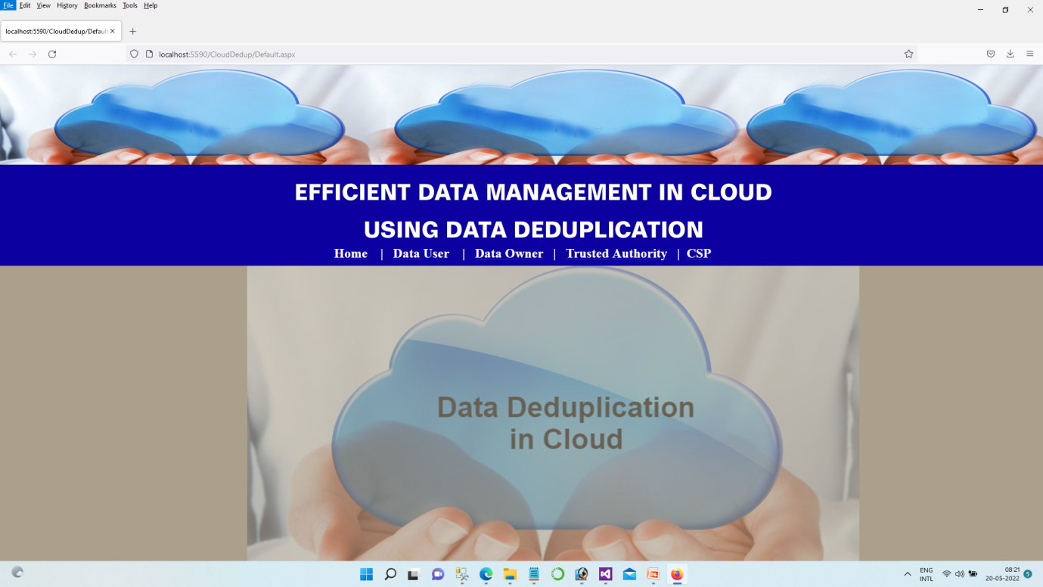

Fig A.1 Home Page

**A.2 Owner Registration**

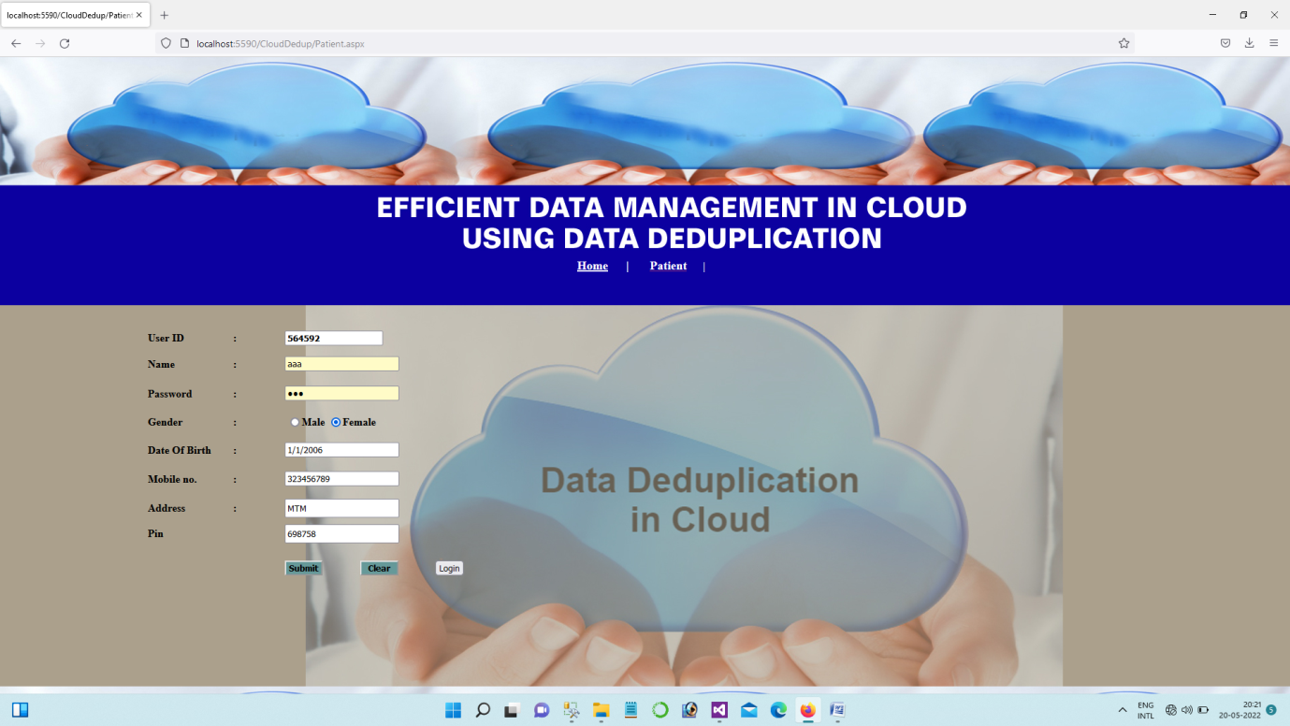

Fig A.2 Owner Registration

**A.3 Data Owner Registration**



Fig A.3 Data Owner Registration

**A.4 Data Owner Login**



Fig A.4 Data Owner Login

**A.5 Health Records**

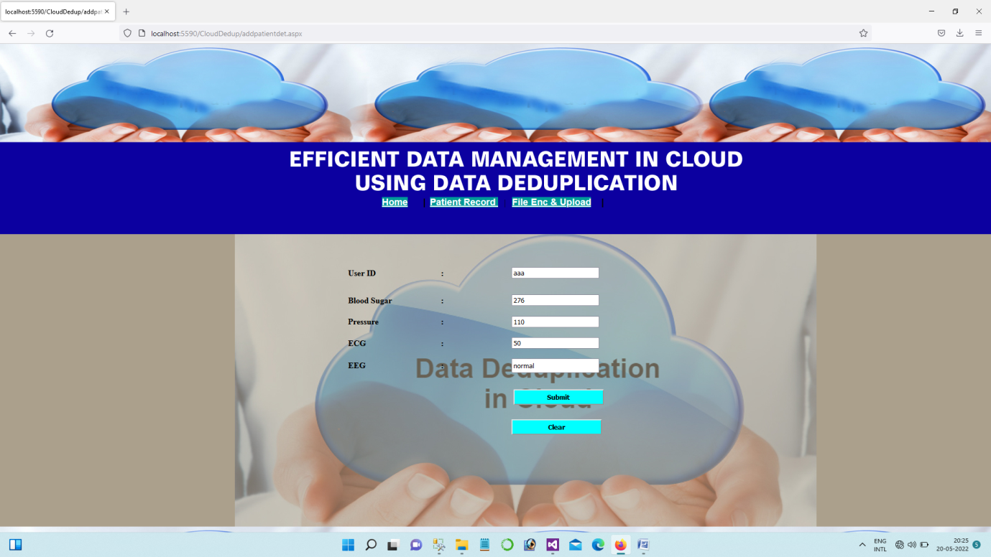

Fig A.5 Health Records

**A.6 File Upload**

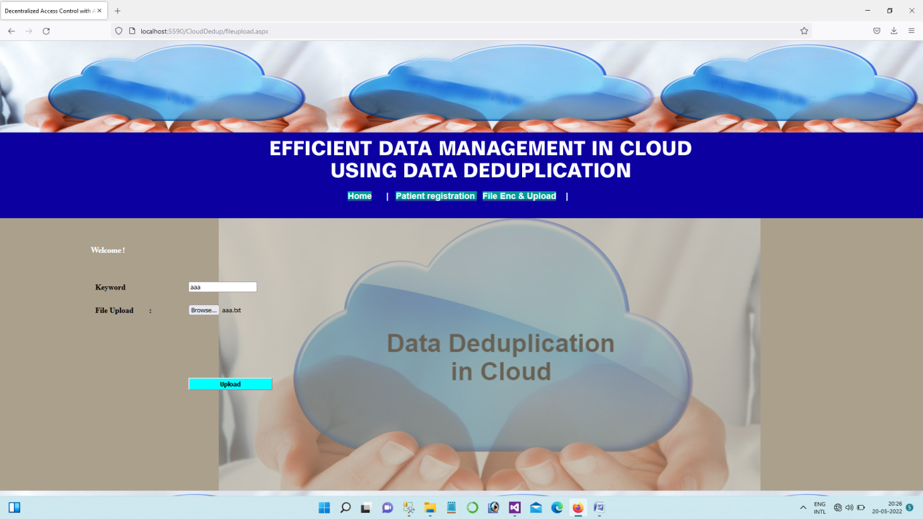

Fig A.6 File Upload

**A.7 User Registration**

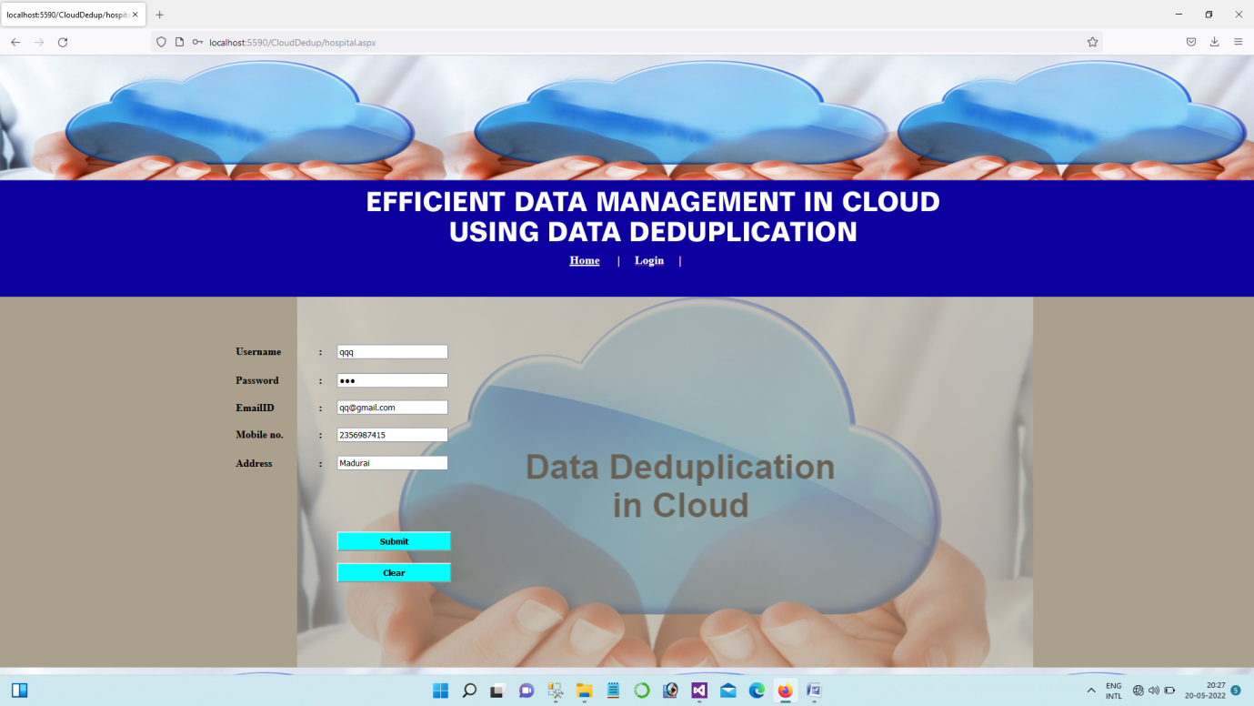

Fig A.7 User Registration

**A.8 User Login**

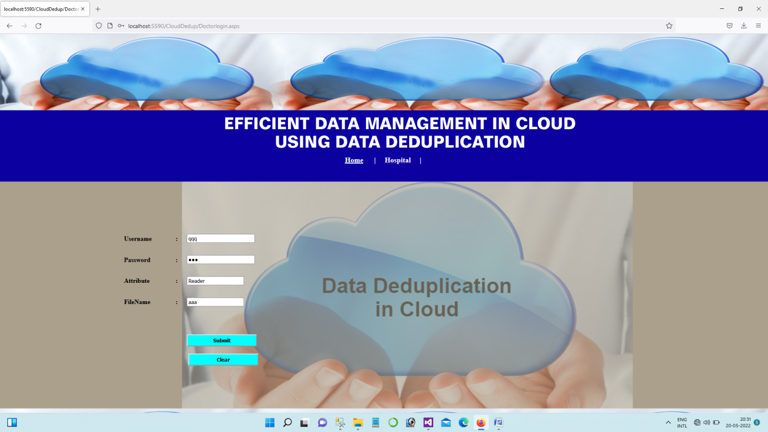

Fig A.8 User Registration

**A.9 Data Access**

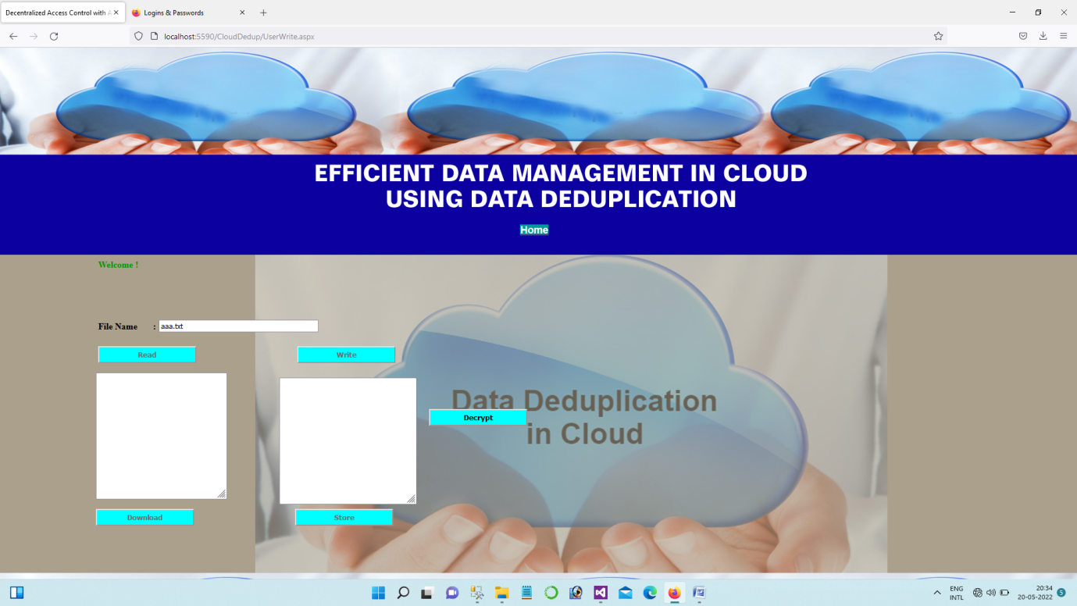

Fig A.9 Data Access

**A.10 TPA Login**

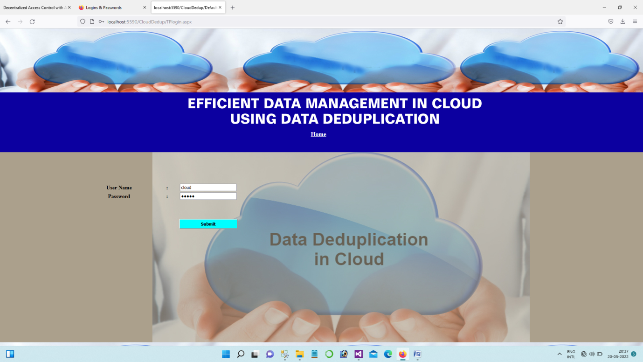

Fig A.10 TPA Login

**A.11 Deduplication Process**

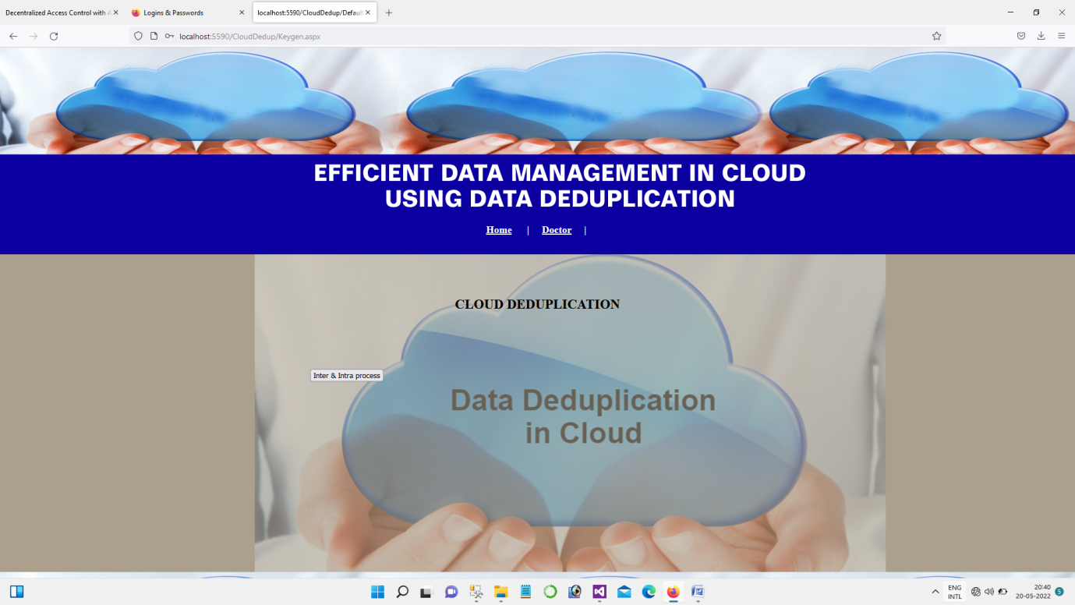

Fig A.11 Deduplication Process

**A.12 Storage Selection**

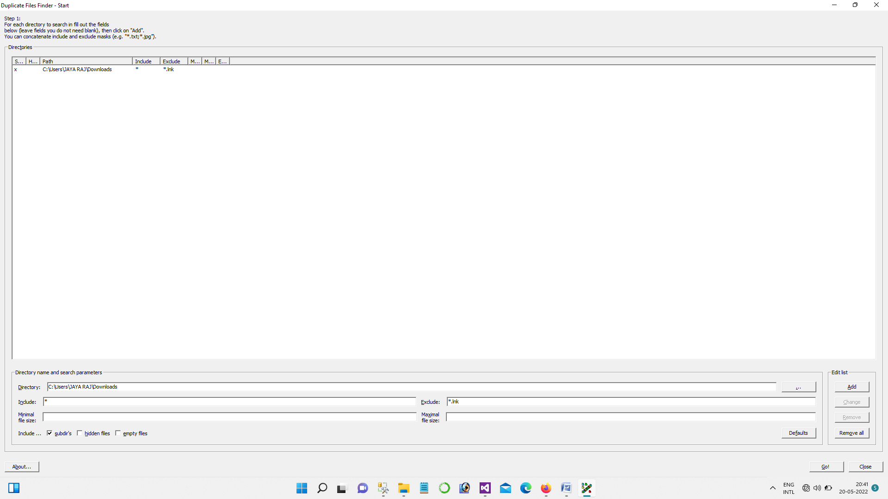

Fig A.12 Storage Selection

**A.13 File Varification**

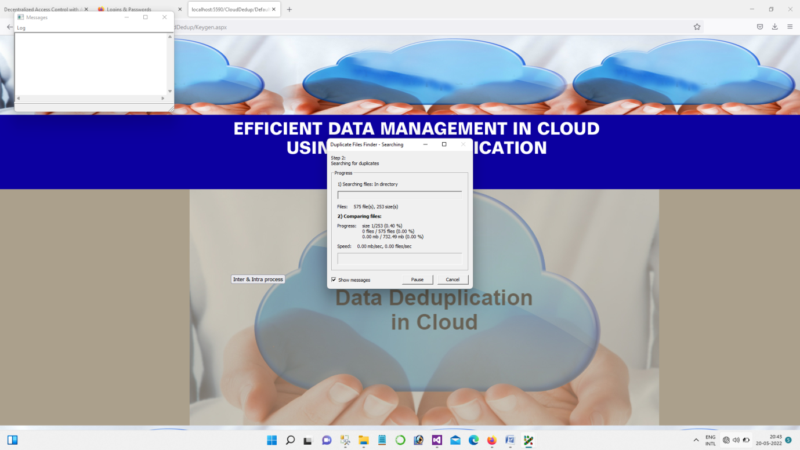

Fig A.13 File Varification

**A.14 Duplicated Files**

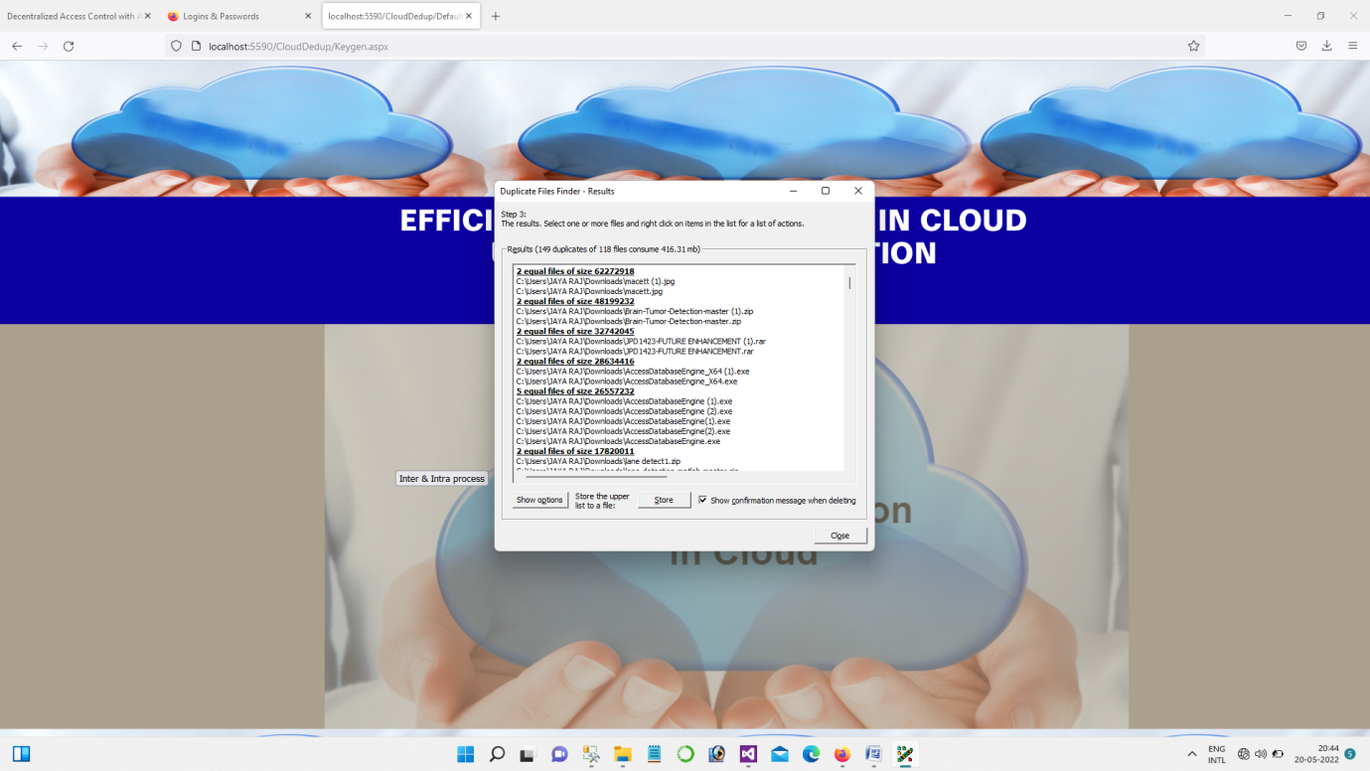

Fig A.14 Duplicated Files

1. **2 About The Choosen Software**

ASP.Net is a part of the .Net framework. As a programmer, you interact with it by using the appropriate types in the class library to write programs and design web forms. When a client request a page, the ASP.Net service runs (inside the CLR environment), executes your code, and creates a final HTML page to send to the client.

.Net Framework

.Net is a "Software Platform". It is a language-neutral environment for developing rich .Net experiences and building applications that can easily and securely operate within it. When developed applications are deployed, those applications will target .Net and will execute wherever .Net is implemented instead of targeting a particular Hardware/OS combination. The components that make up the .Net platform are collectively called the .Net Framework.

The .Net Framework is a managed, type-safe environment for developing and executing applications. The .Net Framework manages all aspects of program execution, like, allocation of memory for the storage of data and instructions, granting and denying permissions to the application, managing execution of the application and reallocation of memory for resources that are not needed. The .Net Framework is designed for cross-language compatibility. Cross-language compatibility means, an application written in Visual Basic. .Net may reference a DLL file written in C# (C-Sharp). A Visual Basic .Net class might be derived from a C# class or vice versa.

The .Net Framework consists of two main components:

* Common Language Runtime(CLR)
* Class Libraries

**Common Language Runtime (CLR)**

The CLR is described as the "execution engine" of .Net. It's this CLR that manages the execution of programs. It provides the environment within which the programs run. The software version of .Net is actually the CLR version.

Working of the CLR

When the .Net program is compiled, the output of the compiler is not an executable file but a file that contains special type of code called the Microsoft Intermediate Language (MSIL). This MSIL defines a set of portable instructions that are independent of any specific CPU. It's the job of the CLR to translate this Intermediate code into a executable code when the program is executed making the program to run in any environment for which the CLR is implemented. And that's how the .Net Framework achieves Portability. This MSIL is turned into executable code using a JIT (Just In Time) complier. The process goes like this, when .Net programs are executed, the CLR activates the JIT complier. The JIT complier converts MSIL into native code on a demand basis as each part of the program is needed. Thus the program executes as a native code even though it is compiled into MSIL making the program to run as fast as it would if it is compiled to native code but achieves the portability benefits of MSIL.

**Class Libraries**

Class library is the second major entity of the .Net Framework. This library gives the program access to runtime environment. The class library consists of lots of prewritten code that all the applications created in VB .Net and Visual Studio .Net will use. The code for all the elements like forms, controls and the rest in VB .Net applications actually comes from the class library. Some reasons why developers are building applications using the .Net Framework:

Improved Reliability

* Increased Performance
* Developer Productivity
* Powerful Security
* Integration with existing Systems
* Ease of Deployment
* Mobility Support
* XML Web service Support
* Support for over 20 Programming Languages
* Flexible Data Access

**Microsoft SQL Serer**

MS SQL Server is a relational database management system (RDBMS) developed by Microsoft. This product is built for the basic function of storing retrieving data as required by other applications. It can be run either on the same computer or on another across a network. This tutorial explains some basic and advanced concepts of SQL Server such as how to create and restore data, create login and backup, assign permissions, etc. Each topic is explained using examples for easy understanding.

**SQL Connection**

These objects allow you to establish a connection, which is the first step in any database operation. They also allow you to start a transaction.

**SQL Command**

These objects represent an SQL statement or stored procedure that you can use against a data source to retrieve, Update, or Modify data. You set information into a command using the Command Type and Command Text properties. You must also link your command to the appropriate connection object using the command object’s connection property.

These objects are similar to the command object in ADO. To actually use your command, you must use a Data Adapter, or use one of the following methods.

**Execute Non Query**

It allows you to execute the command without retrieving any information. This is ideal for an insert, update, or delete operation using an SQL statement or stored procedure.

**Execute Reader**

It creates a Data Reader object, which provides a fast forward-only connection that allows you from the data source.

**Execute Scalar**

Execute Scalar also creates a Reader, but it only returns a single value: the first column from the first row of the resulting row set.

**SQL Data Reader**

SQL Data Reader objects provide a steady stream of data.They are the fastest way to read data when all you want to do is display it in a web page, and you don’t need any capability to manipulate or update it later on. These classes are the equivalent of ADO’s fast forward-only cursor. They maintain alive connection with a data source, but they don’t allow any changes. To get a row of information from an SQL Data Reader object, you use the read method.

**SQL Data Adapter**

These objects, which derive from the common Data Adapter class, act as a bridge between a command and a data set. For example you can create an SQL statement that selects a set of rows, create a command that represents it, and use the SQL Data Adapter object to automatically retrieve all the matching values and insert them into a supplied data set.

* Fill executes the Select Command and places the result into the Data Set you supply
* Fill Schema uses the Select Command to retrieve information about a table, such as column constraints, and add it to a DataSet. No data rows are transferred.

Update scans through the supplied Data Set, and applies all the changes it finds to the data source.

**A.3 Sample code**

using System;

using System.IO;

using System.Collections.Generic;

using System.Linq;

using System.Web;

using System.Web.UI;

using System.Web.UI.WebControls;

using System.Data.SqlClient;

using System.Configuration;

public partial class OwnerRegister : System.Web.UI.Page

{

SqlConnection con = new SqlConnection(ConfigurationManager.ConnectionStrings["CloudHealth"].ConnectionString);

protected void Page_Load(object sender, EventArgs e)

{

con.Open();

SqlCommand cmd2 = new SqlCommand("select max(PatID) from patnew", con);

SqlDataReader dr = cmd2.ExecuteReader();

while (dr.Read())

{

string patid = dr.GetValue(0).ToString();

int pidd = int.Parse(patid.ToString());

int pid = pidd + 1;

TextBox8.Text = pid.ToString();

}

con.Close();

}

protected void Button1_Click(object sender, EventArgs e)

{

string gend = RadioButtonList1.SelectedItem.ToString();

// Session["bgroup"] = TextBox7.Text;

// Session["addr"] = TextBox6.Text;

int dd = 456;

con.Open();

SqlCommand cmd = new SqlCommand("insert into patnew1 values('" + TextBox1.Text + "','" + TextBox2.Text + "','" + gend + "','" + TextBox3.Text + "','" + TextBox5.Text + "','" + TextBox6.Text + "','" + TextBox7.Text + "','" + TextBox8.Text + "','" + dd + "')", con);

cmd.ExecuteNonQuery();

con.Close();

Label16.Text = "Registered Successfully....";

clear();

}

protected void Button2_Click(object sender, EventArgs e)

{

clear();

}

public void clear()

{

TextBox1.Text = "";

TextBox2.Text = "";

TextBox3.Text = "";

//TextBox4.Text = "";

TextBox5.Text = "";

TextBox6.Text = "";

}

protected void Button3_Click(object sender, EventArgs e)

{

Response.Redirect("Patientlogin.aspx");

}

}

using System;

using System.IO;

using System.Collections.Generic;

using System.Linq;

using System.Web;

using System.Web.UI;

using System.Web.UI.WebControls;

using System.Data.SqlClient;

using System.Configuration;

public partial class addpatientdet : System.Web.UI.Page

{

SqlConnection con = new SqlConnection(ConfigurationManager.ConnectionStrings["CloudHealth"].ConnectionString);

protected void Button3_Click(object sender, EventArgs e)

{

// string gend = RadioButtonList1.SelectedItem.ToString();

con.Open();

SqlCommand cmd = new SqlCommand("insert into healthrecord values( '" + TextBox8.Text + "','" + TextBox3.Text + "','" + TextBox4.Text + "','" + TextBox5.Text + "','" + TextBox6.Text + "')", con);

cmd.ExecuteNonQuery();

con.Close();

Label16.Text = "Submitted Successfully....";

// Session["bgroup"] = TextBox7.Text;

// Session["addr"] = TextBox6.Text;

String kk = "Patient ID : " + TextBox8.Text + " " + "Blood Sugar : " + TextBox3.Text + " " + "Pressure : " + TextBox4.Text + " " + "ECG : " + TextBox5.Text + " " + "EEG : " + TextBox6.Text;

// File.Create("C:/inetpub/wwwroot/BlookbankCloud/Cloud sourcecode/hospital" + TextBox8.Text + ".txt");

File.Create("C:/inetpub/wwwroot/CloudHealthCare/hospital/" + TextBox8.Text + ".txt");

string path = null;

path = Server.MapPath("~/hospital" + TextBox8.Text + ".txt");

File.WriteAllText(path, kk.Trim());

TextBox3.Text = "";

TextBox8.Text = "";

TextBox4.Text = "";

TextBox5.Text = "";

TextBox6.Text = "";

}

protected void Button4_Click(object sender, EventArgs e)

{

// TextBox1.Text = "";

TextBox8.Text = "";

TextBox3.Text = "";

TextBox4.Text = "";

TextBox5.Text = "";

TextBox6.Text = "";

// TextBox7.Text = "";

}

protected void Page_Load(object sender, EventArgs e)

{

TextBox8.Text = Session["ppid"].ToString();

Random rd = new Random();

int p1 = rd.Next(70, 500);

TextBox3.Text = p1.ToString();

Random rd1 = new Random();

int p2 = rd.Next(80, 150);

TextBox4.Text = p2.ToString();

Random rd2 = new Random();

int p3 = rd.Next(40, 100);

TextBox5.Text = p3.ToString();

TextBox6.Text = "normal";

}

protected void TextBox8_TextChanged(object sender, EventArgs e)

{

}

}

using System;

using System.Collections.Generic;

using System.Linq;

using System.Web;

using System.Web.UI;

using System.Web.UI.WebControls;

using System.IO;

using System.Text;

using System.Security;

using System.Security.Cryptography;

using System.Runtime.InteropServices;

using System.Text.RegularExpressions;

public partial class UserWrite : System.Web.UI.Page

{

protected void Page_Load(object sender, EventArgs e)

{

string gg = Session["key"].ToString();

TextBox3.Text = gg + ".txt";

}

private void DecryptFile(string inputFile, string outputFile)

{

try

{

string password = @"myKey123"; // Your Key Here

UnicodeEncoding UE = new UnicodeEncoding();

byte[] key = UE.GetBytes(password);

FileStream fsCrypt = new FileStream(inputFile, FileMode.Open);

RijndaelManaged RMCrypto = new RijndaelManaged();

CryptoStream cs = new CryptoStream(fsCrypt,

RMCrypto.CreateDecryptor(key, key),

CryptoStreamMode.Read);

FileStream fsOut = new FileStream(outputFile, FileMode.Create);

int data;

while ((data = cs.ReadByte()) != -1)

fsOut.WriteByte((byte)data);

fsOut.Close();

cs.Close();

fsCrypt.Close();

}

catch { }

}

protected void Button3_Click(object sender, EventArgs e)

{

if (File.Exists(Server.MapPath("~/decrypt/") + TextBox3.Text))

{

TextBox1.Text = File.ReadAllText(Server.MapPath("~/decrypt/") + TextBox3.Text);

}

else

{

TextBox1.Text = File.ReadAllText(Server.MapPath("~/encrypt/") + TextBox3.Text);

}

}

protected void Button4_Click(object sender, EventArgs e)

{

TextBox1.Text = TextBox1.Text + TextBox2.Text;

}

protected void Button2_Click(object sender, EventArgs e)

{

string encfil = Server.MapPath("~/encrypt/") + TextBox3.Text;

string decfil = Server.MapPath("~/decrypt/") + TextBox3.Text;

DecryptFile(encfil, decfil);

Button1.Enabled = true;

Button3.Enabled = true;

Button4.Enabled = true;

Button5.Enabled = true;

}

protected void Button1_Click(object sender, EventArgs e)

{

string filename = Server.MapPath("~/decrypt/") + TextBox3.Text;

FileInfo fileInfo = new FileInfo(filename);

if (fileInfo.Exists)

{

Response.Clear();

Response.AddHeader("Content-Disposition", "attachment; filename=" + fileInfo.Name);

Response.AddHeader("Content-Length", fileInfo.Length.ToString());

Response.ContentType = "application/octet-stream";

Response.Flush();

Response.WriteFile(fileInfo.FullName);

Response.End();

}

}

protected void Button5_Click(object sender, EventArgs e)

{

TextWriter tw = new StreamWriter(Server.MapPath("~/decrypt/") + TextBox3.Text);

tw.WriteLine(TextBox1.Text);

tw.Flush();

tw.Close();

}

}